* Correlation can be checked between multiple independent variables
* We can also check for Transform of variable if there is much non similarity in values of independent variables
* 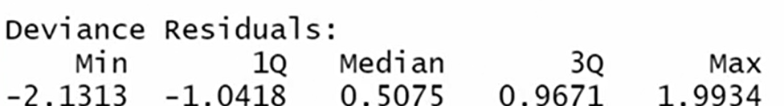



* Coeff is best guess model from our data of how much this affects our outcome
* Std error tells how much the coefficient might wiggle around if we repeat this model with different data
* Is there any dataset on which might we apply this factor and this

coefficient might become 0 rather than current value considering possible variation

* This can be checked by finding min and max values of coefficient by adding/subtracting std error and we can see that it is most likely in only X2
* High Z means there is considerable gap from your coefficient ever becoming zero in any dataset
* P > 0.05 or 50% means yes there are some cases in which actual coefficient is 0 but we surprisingly predicted a value
* 0.025 and 0.975 means that we are 95 % confident that our values lie between these ranges although little even far from variations

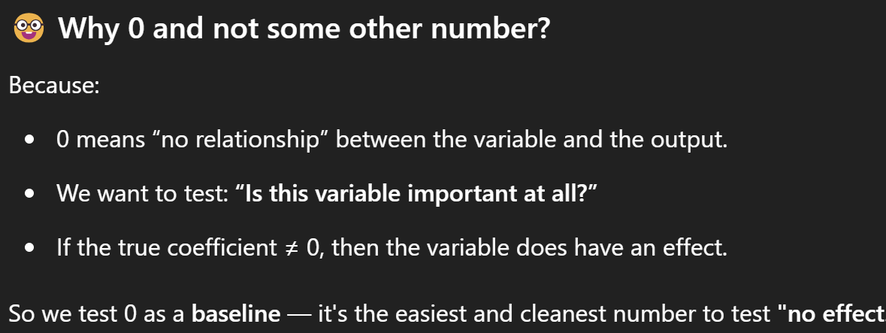

* Link Function : Logit function or sigmoid curve is used to connect input and outputs and also relation between predict and actual
* Covariance tells which method was followed for error calculation
* No of Iterations : How many steps model took for finding best parameters

Model uses only all rows for pattern and evaluates 4 parameters and df residual is the difference used for testing and feedback

AIC values

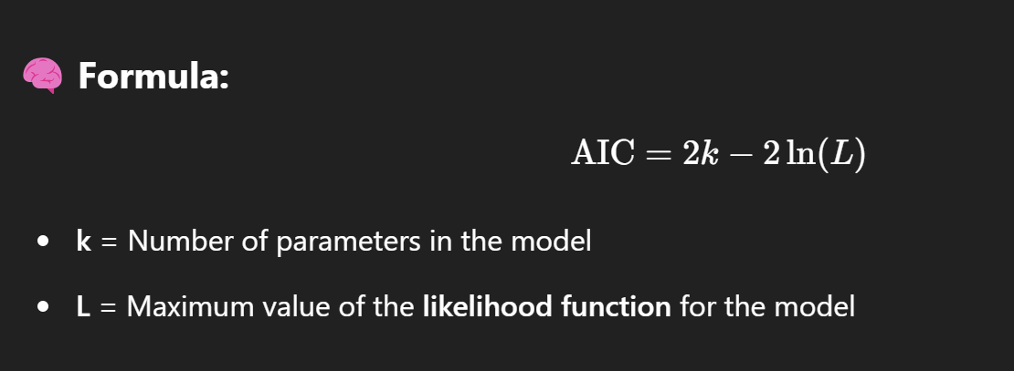

Used by model in comparison between different regressions like poisson regressions and logistic regressions